Question 1. (15 Marks) [START A NEW PAGE] Marks
a) Given that 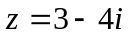 and 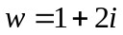, write down the values of each 5
of the following, expressing your answers in simplest form.

i) ii) 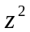 iii) 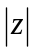 iv) 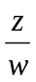 v) arg(w)

b) (Detach and use the sheet provided)
On the Argand diagram provided, the points A and B represent the 5
complex numbers α and β respectively. On the same sheet construct,
with the aid of geometrical instruments, points P,Q, R, S and T which
respectively represent:

i) α + β ii) – β iii) α – β iv) 2iβ v) 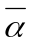

Clearly indicate any significant lengths and angles.

(Ensure that the Argand diagram is handed in with the rest of question 1.)

c) i) Find all real numbers x and y that satisfy 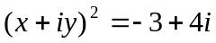. 3

ii) Hence solve the equation 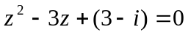 2

Question 2. (15 Marks) [START A NEW PAGE] Marks

a) A complex root of 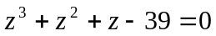 is known to be 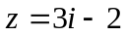. 3
Deduce the values of the other two roots, giving reasons for your answers.

b) i) If z = 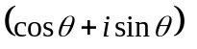, use de Moivre’s Theorem to prove that 3
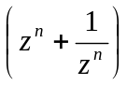 = 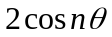.
ii) Hence, or otherwise, prove that 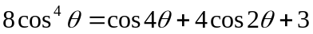 . 2

c) z satisfies 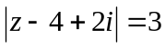 and w satisfies 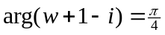. The point P
represents z on an Argand diagram and Q represents w .

- Sketch the loci of P and Q on an Argand diagram. 4

ii) If 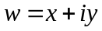 , write down the equation of the locus of Q in terms of x and y. 2

- Hence deduce the minimum value of 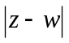. 1

Question 3. (15 Marks) [START A NEW PAGE] Marks
a) i) Express 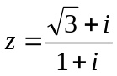 in mod-arg form. 3
ii) Hence find the smallest positive integer m for which 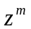 is real. 2

b) i) On an Argand diagram, sketch the locus of points which satisfy the 2
relationship 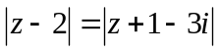, clearly showing its position and orientation.
- On the same Argand diagram, sketch the locus of 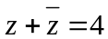. 2

iii) Shade the area where 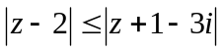 and 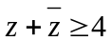 simultaneously. 1

c) The points A, B and C represent z₁, z₂ and z₁ + z₂ in an Argand diagram
where z₁ and z₂ satisfy the relationship
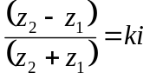 where k is a positive number (and 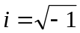).
- Illustrate such an arrangement on an Argand diagram, denoting clearly 2
properties of the quadrilateral OACB and its diagonals (O is the origin).

- What is the shape of the quadrilateral OACB if α) 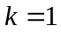 β) 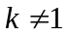. 2

iii) Write down the area of the quadrilateral OACB in terms of z₁ and z_{2 .} 1

Question 4. (15 Marks) [START A NEW PAGE] Marks

a) i) Solve the equation 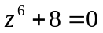, writing the roots in mod-arg form. 3

ii) Illustrate these roots on a clear Argand diagram. 2

- Write 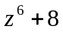 in factorized form over the field of Real numbers. 3

b) The diagram shows an isosceles triangle ABP in the
Argand diagram, with base AB and 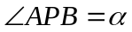.
PM is the perpendicular bisector of AB and so bisects
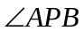. Given that A and B represent the complex
numbers z₁ and z₂ respectively, find, in terms of z₁, z₂
and α , the complex numbers represented by:

- the vector AM. 2

- the vector MP. 3

Hence show that P represents the complex number
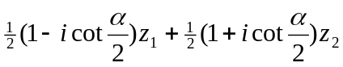 . 2

(END OF EXAMINATION)
Student Number : _________________________

Use this diagram for Question 1(b) and hand it in with the rest of your answers to question 1.

